
Nisemonogatari Vol. 2

Tsukihi Phoenix
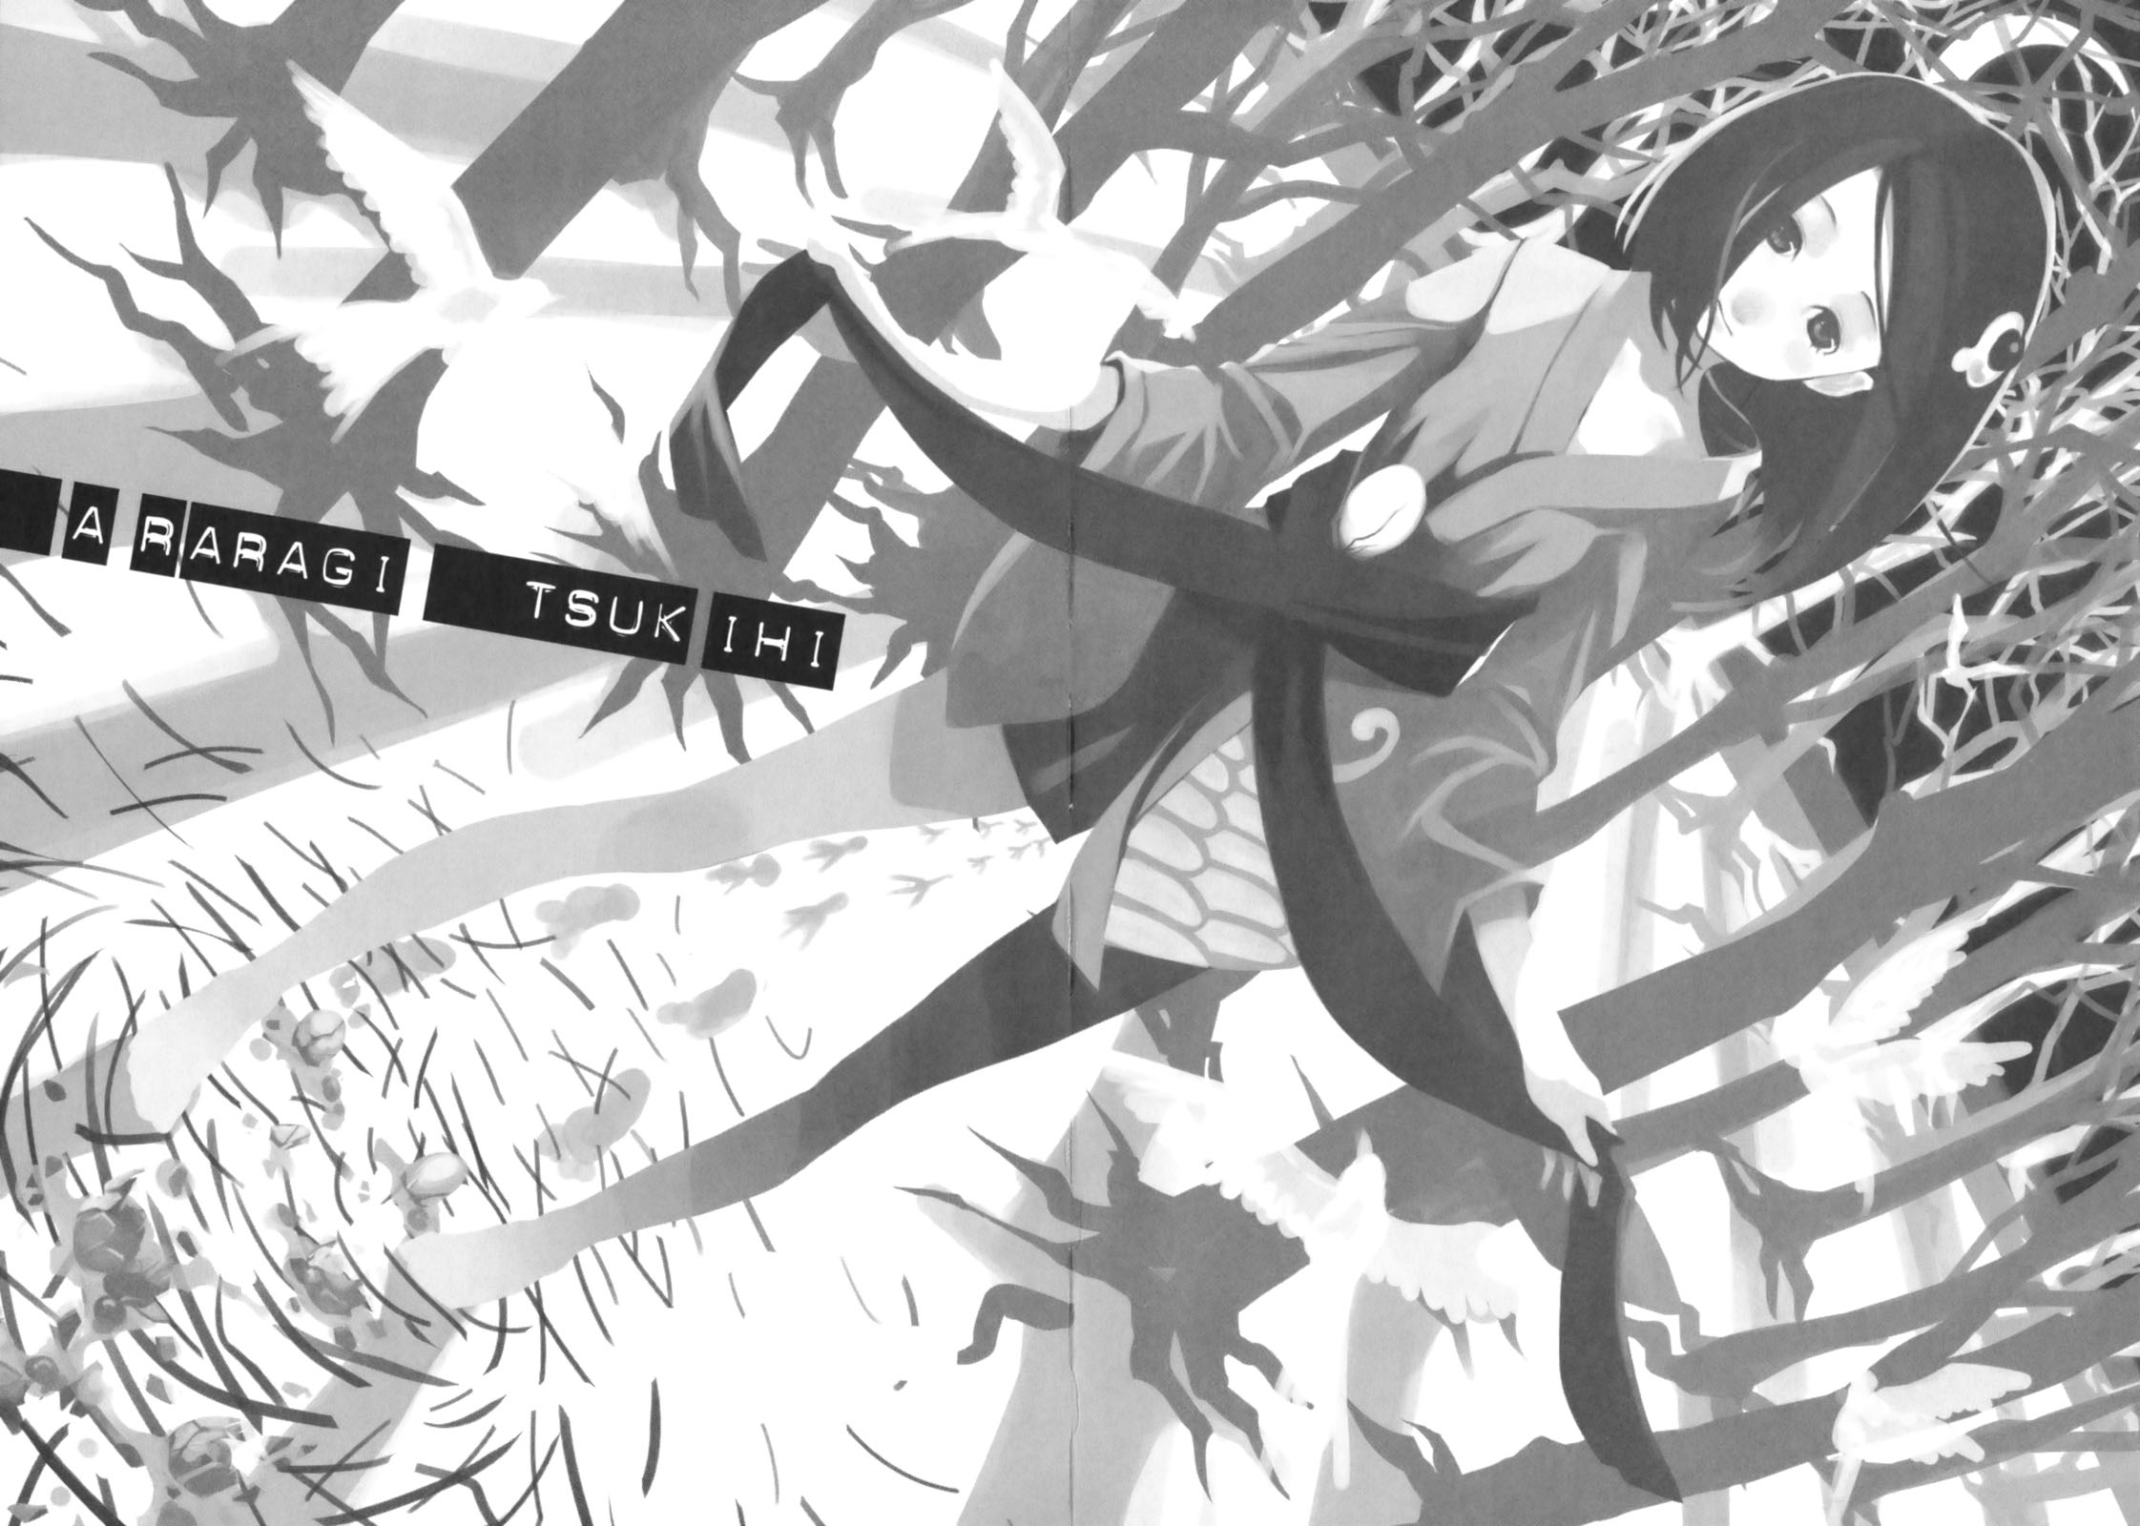

THIS IS JUST A ROUGH DRAFT.
As we get closer to the end of our story, the true nature of Araragi Tsukihi can be seen. She is clever and fussy, and when my youngest sister’s talking, I should be more loving to her like a group of friends at the end of an episode. With that said I’m not talking about the end of the episode where someone dies or it’s the end of the world. Why is it that until someone’s life is about to be taken, or to be more general until the end of someone’s life or the end of the world? How far do things have to go before people get help? For us that kind thing is normal to think about while thinking about random things. Even if something ends, everything has not ended. Even if something has stopped not everything has stopped. This kind of hell is the everyday world we live in, even though our world is filled with abnormalities. These abnormalities that I have experienced before and these abnormalities that I will continue to experience through unforeseen courses of events.
However I,
Araragi Koyomi
Last spring I was attacked by a vampire----- I was attacked by the traditional kind of vampire. The iron blooded, hot-blooded, cold-blooded vampire also known as the kaii killer and king of kaiis.
She sucked my blood until there was nothing left. She sucked my life until there was nothing left. She sucked out my existence until there was nothing left. She sucked my physical body until it was nothing. After she was done there was nothing that remained. No.
Afterwards what remained was a monster.
After pulling me from myself, what remained was a monster.
Trying to avoid the unavoidable, to escape the inescapable, to die without dying---- Those two weeks were like hell. And from there is where it started. Also those two weeks of hell, even now it’s hard to say that a perfect conclusion was reached---- and of course. In my case there is nothing that can support what happened. It ended the way it began in a word it was unreal.
For my life I chose to be a person that was cut off from others. There are plenty of people in this world--- however in the greater scheme of things one cannot say everything will just end. The life I chose is one that will end in suicide. Then I had a new perspective during the start of the new school year.
Justice is the annihilation of evil. This only brings about a new kind of evil.You can annihilate evil however no one has the right to exterminate evil--- On the contrary; a new kind of evil is born. It might have been the case that evil started on the side of justice.
For example, I can think of one person who would complain and say that this is wrong: my younger sister, Karen. All her complaints should have already completely been addressed, but the anger in her heart lead her to reject what I had to say to my face with her foot. (I don’t know how to put in foot notes, but the pun here is that the word for reject is also the word for kick. So she rejected him to his face and certainly kicked him in the face as well.) "I'm not rejecting anything; I have justice flowing through my veins." Or, something like that is what you could expect to hear her say.
However I didn’t even know her.
I taught without knowing her.
It was nothing outrageous.
In this peaceful and carefree country, we received a normal education. However, I don’t know---- Things like the existence of justice after all. There is the new kind of justice where justice is upheld by violence. (joke incoming!!!) the only person who says this kind of thing is my youngest sister. That was just the opening act. (All in all this was just the beginning.)

